Nurse and Midwife Medicinal Product Prescribing Toolkit

Audit of Nurse and Midwife Medicinal Product Prescribing Practices
Sample Template for Clinical Audit Report

June 2020

Changing practice to support service delivery

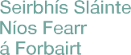
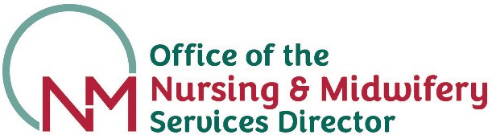

1

Audit of Nurse and Midwife Medicinal Product Prescribing Practices Sample Template for Clinical Audit Report

Title of Audit:
Date of Report:
Department/Specialty: |  | Re-audit date:

Audit lead/Author: |  | Job Title:
Health Service Provider:
Key Stakeholders: | Names: | Department/Specialty:

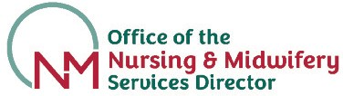
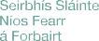

2

Background & Aim:

Say why the audit was undertaken, e.g fulfilling NMBI requirement for auditing nurse and midwife prescribing. State what the audit is trying to achieve:
Standard/Criteria Selection:

Eg: Practice Standards and Guidelines for Nurses and Midwives with Prescriptive Authority (NMBI, 2019)

National Guideline for Nurse and Midwife Medicinal Product Prescribing (HSE, 2020)
Methodology:

State
- Chosen population

- How sample selected

- Retrospective

- Sample size

- Identify tool used
Results:

State the results. Start with total number (n =). Data may be presented visually (graphs, tables)
Conclusion:

List key points that emerge from results
Recommendations:

Bullet point action plan with review date and initials of person in charge of implementation. If required, a quality improvement plan can be developed.

